WINE & CULINARY TOUR
OF PORTUGAL, SPAIN & FRANCE

DATES:
2024, May 21st to 30th
Max out at 16/18 guests
RSVP
Silvia Amador: +1 (619) 618-5464/sam@missioncellarswinery.net
The tour includes all breakfasts, a total of 21 meals during the course of the trip, nine nights of hotel accommodation, all winery tours and tastings, all other tours listed below and private bus transportation. Air, train and taxi fares are not included. Members and Guests will be accommodated on a first-come first-served basis. If we can make the trip better, changes can be made.

ITINERARY

DAY 0:

Lisbon, Sintra or Cascais are beautiful places to visit in Portugal. We are sure you are going to arrive a couple of days before the tour. Here are a few recommendations for you. With a dedicated and funny guide, you and your private party can spend half a day exploring different areas of Lisbon. You can take a tour of the famous Pena Palace and Quinta da Regaleira then head to stroll through the fishing village of Cascais. The bus will pick you up and drop you off at the hotel at your convenience. Here are a few of those tours:

https://www.viator.com/tours/Lisbon/Lisbon-Half-Day-Private-Tour/d538-17394P11

https://www.viator.com/tours/Lisbon/Sintra-Cascais-and-Estoril-Private-Full-Day-Sightseeing-Tour-from-Lisbon/d538-23747P28

DAY 1: 21st of May (B/L):
Today, the first day of the tour, we will wait for you in the Lobby of the Hotel. We will go to the Palacio Museo da Bacalhoa, in Sintra, Lisbon. We will do a personalized tour of the winery where we are going to taste several wines, we will check the museum and explore the beautiful grounds. You will love it! After this fun first adventure, we will go for lunch and then back to the hotel. You will have time to rest and enjoy Sesimbra during the night.

Hotel Tonight: SANA Sesimbra Hotel, Sesimbra, Lisbon, Portugal

MAP 1:
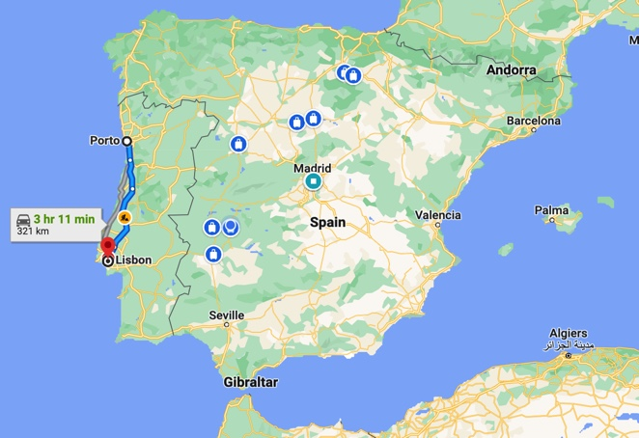
Estimated time form Lisbon to Porto: 3h11m.

DAY 2: 22 of May (B/D)

Breakfast in the hotel.

At 9 am we will wait for you in the Lobby. Our bus is waiting for us to go to Porto. We will go directly to visit a wonderful winery and taste some wines. After, we will go to our Hotel: Hilton Hotel, a hotel carefully selected with a welcome Champagne and wine in the beautiful panoramic bar overlooking the Douro river and the historic center of the city of Porto, UNESCO World Heritage site. We will go easy today, because we are probably starting to feel jet lag after so many hours flying. So, you should expect a welcome brunch in the Hotel to enjoy yourself and in the evening, relax the rest of the day in Porto on your own and then in the evening, we will go and enjoy a wonderful Fado Dinner show together.

Back to the hotel to sleep.

Hotel Tonight: Hilton Hotel, Porto, Portugal.

MAP2:
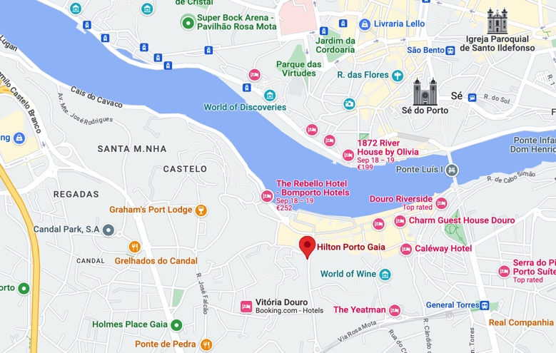
Today, Porto City time!

Day 3: 23 of May (B/L)

Breakfast in the hotel

Today we will stay around Porto today enjoy several wineries during the day and enjoy the night with a fabulous Fado show. The wineries we are visiting are Calem, Sandeman, Graham’s, Burmester or Ferreira as great options. They are all located in the city of Porto and near the hotel. Nest, we will go for lunch together and after you are on your own. We recommend to exploring the WOW (Word of Wine) museum in Porto with the option to visit one of the 5 Museums in the District (Wine Museum, Cork Museum, Chocolate Museum, The Bridge Collection or Pink Palace), you will find elegant shopping, restaurants and more. The whole district is amazing. If you need any other suggestions let us know and we can give some other options as well. In any case, we will give you freedom to explore and we will see you the next day in the Lobby at 9 am.

Hotel Tonight: Hotel Hilton, Porto, Portugal.

Day 4: 24 of May (B/D)

Breakfast on the cruise.

At 9 am, we will be in the lobby as we are taking a cruise! Let’s soak up the beauty of Northern Portugal on a full-day cruise on the Douro River. We will explore the heart of the Douro Valley, classic villages that embody traditional Portuguese charm. The best way to see it? By boat, of course. Enjoy breakfast onboard the vessel as you cruise up the Douro River, admiring the lush mountains and peaceful waters. Disembark and taste some wine. Visit a renowned winery estate and enjoy tasting samples of exquisite Douro Valley Wines. Dinner will be in Quinta da Pacheca where we are going to sleep in Wine Barrels today.

Hotel Tonight: Quinta da Pacheca, Lamego, Portugal

Map:
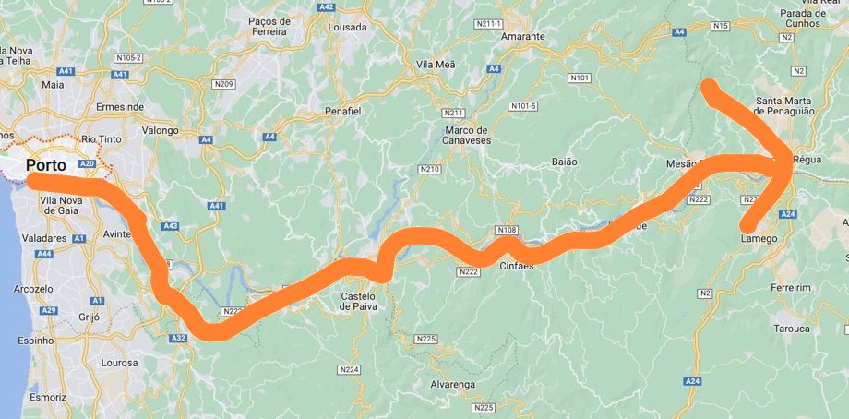

Day 5: 25 of May (B/D)

Breakfast in the Hotel.

Get ready to cross the border. On to Spain: here we go! We will depart at 9 am from the Hotel Lobby. We will go to Toro, Zamora, to explore the wine in Ribera del Duero. We will stay in a SPA hotel to die for. In Toro, we will visit La Colegiata, the Celtic Bull, the Walls and we will drink a glass of wine or two in town. Also, you can expect to visit the Families own Winery of Vocarraje, our friends and they will show us La Jolla of the Crown: “the French wine from Bernard Magrez”. Exciting, right?

Hotel Tonight: Hotel Convento, Toro, Zamora, Spain

MAP 6:
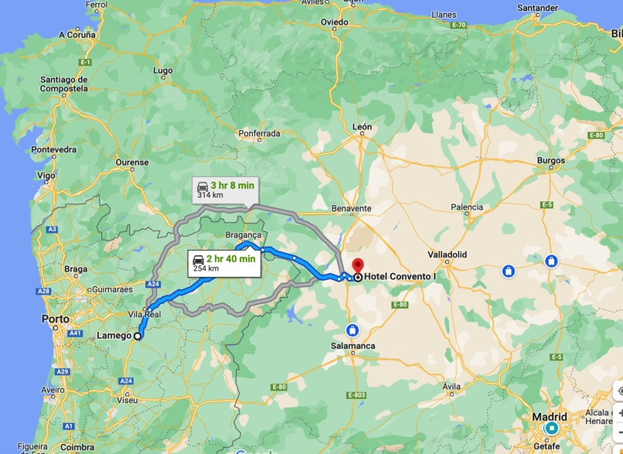

Day 6: 26 of May (B/L)

Breakfast in the Hotel

This day, we will head to the beautiful La Rioja, in the North of Spain. The ride is going to be 3h and 8 minutes. When we arrive in La Rioja, our first step is going to be Museum Vivanco in Briones. We will learn about the history of wine, grapes, winemaking and the evolution of winemaking technology at the Museum Vivanco. We will also visit the Vivanco Winery on site and taste their wine up on the top floor overlooking the beautiful vineyards and grounds. After that, we will check in to the Hotel Santa Maria, in Briones, where we will stay one night. Lunch will be in this beautiful town. Enjoy it!

Hotel Tonight: Santa María de Briones, Briones, La Rioja, Spain

MAP 7:
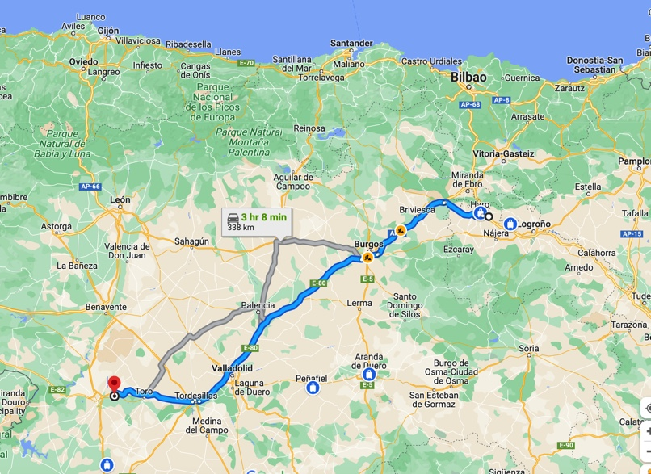

Day 7: 27 of May (B/L)

Breakfast in the Hotel

Today, we will go and check in at the 5* Hotel Domine Bilbao, next to Museum Guggenheim. After we arrive, we will explore the Museum Guggenheim and the outside area and go for dinner at 8 pm at Bistro Restaurant. Basque cuisine is world renown, and we will have a chance to experience it in this wonderful and classy restaurant about to receive a Michelin Star.
For those that want to be in their own, we have different options:

- Join a private walking tour of Bilbao for a personalized exploration of this beautiful city. There is no need to stick to a set itinerary or deal with large groups of tourists on this tour. Instead, your guide will pick you up from your hotel for an easy start and then take you to the best spots in the city and some hidden spots you'd never find on your own.

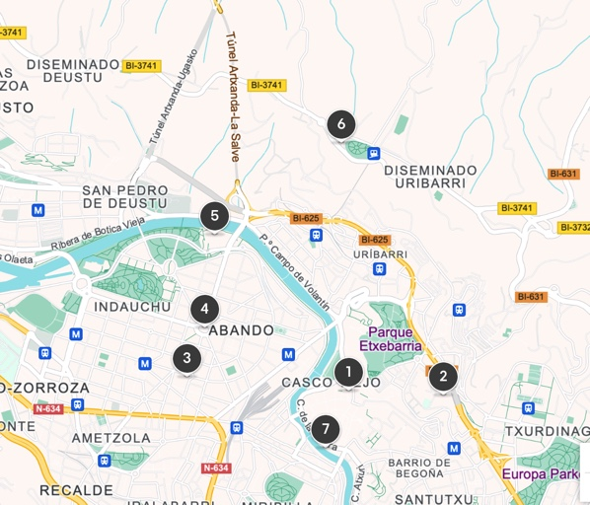

Itinerary:

1. Old Town
Stop: 60 minutes

2. Basilica of Begoña
Stop: 20 minutes

3. Azkuna Zentroa
Stop: 30 minutes

4. Plaza Moyúa
Stop: 30 minutes

5. Guggenheim Museum Bilbao
Stop: 60 minutes

6. Artxanda Viewpoint
Stop: 60 minutes - Admission included

7. La Ribera Market
Stop: 15 minutes

You will return to the starting point, OR….

- At 11 am you can join a fantastic Private Workshop Preparation of Pintxos with Lunch in Bilbao, for about 2 hours. The Kitchen is located in the old town of Bilbao, near the Mercado de la Ribera (the main food market in the city), the Cathedral of Santiago and the Church of San Antón. The old town of Bilbao is a place full of history and traditions of the Basque Country. We will learn to make 4 Pintxos (Tapas) so that you can prepare them at home and impress your guests. All this in a quiet and pleasant environment, perfect for enjoying ourselves and making new friends.
Here a sample Menu:
Starter 1: Modernist Gilda. A typical Bilbao pintxo that we will modernize with an olive esterification.
Starter 2: Low temperature cod with pil pil sauce. Cod at its perfect cooking point with a typical sauce from the Basque Country.
Starter 3: Chop tar tar toast. A steak in its pintxo version.
Dessert: Gatzatua with honey and nuts. A delicious sheep curd with honey from nearby farmhouses and nuts.

Alcoholic Beverages Included.

And of course, after we prepare the pinxtos, we will have a chance to enjoy them.

Hotel Tonight: 5* Hotel Domine Bilbao, Bilbao, Basque Country, Spain

MAP 9:
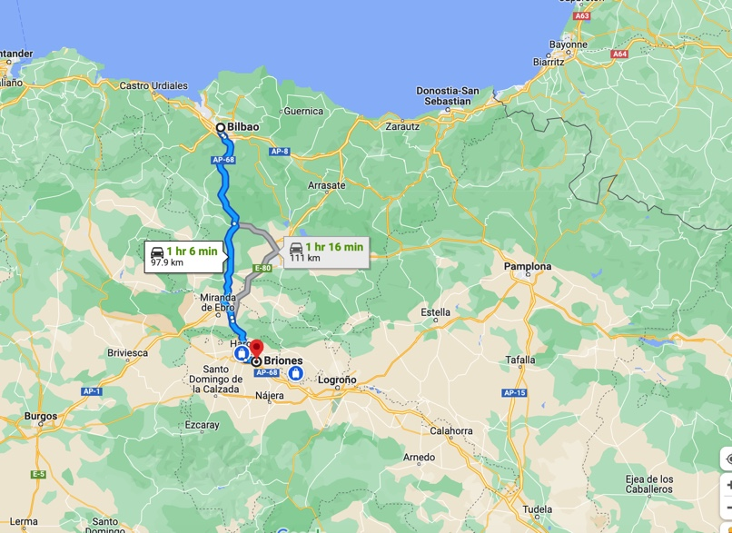

Day 8: 28 of May (B/L)

Breakfast in Hotel

Today we depart to Saint Jean de Luz in France. Get ready to cross the border again today and admire the views. Saint-Jean-de-Luz is a fishing town at the mouth of the Nivelle River, in southwest France’s Basque country. The Saint-Jean-Baptiste Church, where King Louis XIV married Marie-Thérèse of Spain in 1660, has a gilded baroque altarpiece and wooden galleries. The turreted Maison Louis XIV is a museum that recreates 17th-century domestic life with period furniture. It includes the King’s Chamber, where Louis XIV slept. Regarding the language spoken in Saint Jean de Luz, Euskara, also known as Basque, prevails. Basque is an ancestral language that has been maintained over the centuries and is spoken by a large part of the population in the Basque Country region.
After we arrive at the hotel, we will go to visit a local winery and have lunch in at a restaurant with regional cuisine. Enjoy the rest of the afternoon in Saint Jean de Luz on your own and get ready for tomorrow. We go to Bordeaux.

MAP 10:
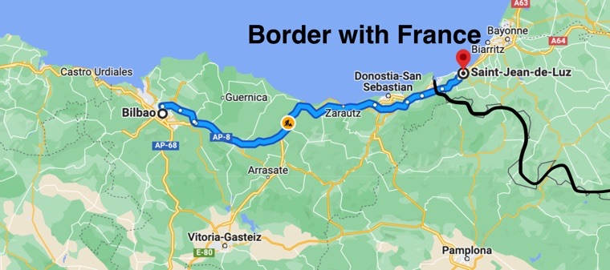

Hotel Tonight: In process

Day 9: 29 of May (B/ Day off to explore)

Breakfast in the Hotel

Today we will depart to our last destination: Bordeaux, France. We will enjoy the “Citè effect”. This term comes from “Guggenheim” in Bilbao. The effect refers to the prodigious economic uplifting of Guggenheim. Opened in 1988 and with 25 million visitors, the audacious building revolutionized the way urban architecture and tourism. Similarly, here in Bordeaux, we can talk about the Citè Effect comparable to the Basque model. The opening of the Citè do Vin in 2016 has indeed spearheaded Bordeaux towards a new destiny. Enjoying the majestic golden tower on the banks of the Garonne River gives visitors from all over the world the opportunity to embark on a playful and sensory journey into the culture, history, and civilizations of wine. The museum’s exhibition trail winds up through a 33,000 sq ft space. It ends with a tasting on a 115 ft high platform boasting splendid panoramic views of the city. This will be a magical moment, not to be missed.

MAP 11:
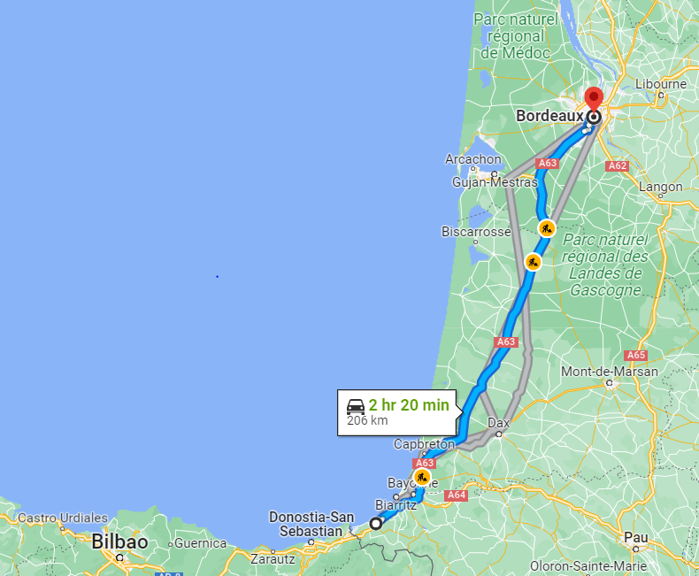

Hotel Tonight: In process

Day 10: 30 of May (B)

Breakfast in the hotel

Trent and Silvia will be there for you to arrange taxis to go to the Bus/Metro or Rental Car to the airport, bus station or train station. Check out will be mid-morning and naturally, the Hotel in Bourdeaux will be more than happy to look after your luggage for the day if you have an evening bus/train.

RSVP
Please reply to this email with everyone in your party's:
1. Full names
2. Cell phone numbers and best date/time to call for your credit card info
3. Email addresses
4. Whether you want one or two beds
5. Whether you want a standard room or a deluxe suit

SIGN UP HERE

…and let’s have fun!

COST: $6.500 per person + tax
DEPOSITS
1st DEPOSIT: 20% non-refundable initial deposit due upon making your reservation
2nd DEPOSIT: 40% non-refundable second deposit due 120 days before tour start date
3rd DEPOSIT: 40% non-refundable final payment due 75 days before tour start date
(Trip cancellation insurance options will be emailed to you if interested).
CALENDAR OF DEPOSITS
MAY 2024
(21st-30th)

1st DEPOSIT* (20%) | $1.300
2nd DEPOSIT (40%) | $2.600  (Around: 10th of January. 2024)
3rd DEPOSIT (40%) | $2.600  (Around: 10th of March. 2024)
- It will be paid through the website: https://www.missioncellars.net/tour-of-spain/. Select the Tour you are interested in, click Register and enter your name email. Then, click on submit and the payment page for the first deposit will show. The following deposits will be open for you a few days before the dates in the chart.
- If you have any questions, you can contact us at any time through the website Chat. Here is how:

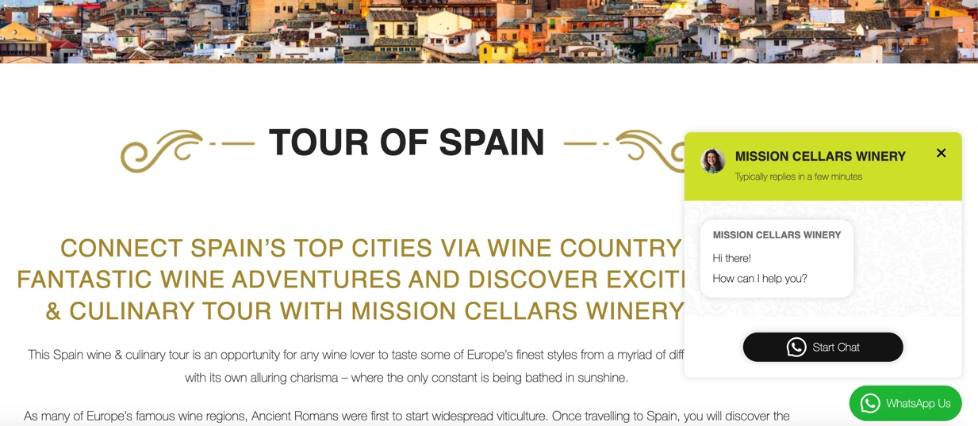
PHYSICAL ABILITY
This tour involves lots of walking that at times will be quite steep and on rocky terrain or uneven cobblestone streets. If you are physically unable to walk up the equivalent of six (6) flights of stairs in less than twenty (20) minutes, please do not make a reservation for this tour.
PASSPORT
Make sure your passport is valid for at least six (6) months past your return date.

Please scroll down for the hour-by-hour itinerary below but here’s an overview of the highlights. This will be a comprehensive, weeklong wine and culinary tour of Portugal, Spain and France including Lisbon, Porto, Ribera del Duero, Basque Country, and Bordeaux.
HOLD HARMLESS AGREEMENT
Upon registration you will be required to sign a hold harmless agreement.
The tour will start in Lisbon and end in Bordeaux, France.

SANA Sesimbra Hotel
Hilton Hotel
https://calem.pt/en/
https://www.sandeman.com/
https://www.grahams-port.com/
https://burmester.pt/en/caves/
https://portoferreira.com/en
https://tickets.wow.pt/#MUSEUM
Hotel Quinta da Pacheca
Hotel Convento
Santa Maria de Briones
https://www.bistroguggenheimbilbao.com/
Hotel Domine Bilbao

