WINE & CULINARY TOUR
OF SPAIN

DATES:
2024, March 4th to 14th
Max out at 16/18 guests
RSVP
Silvia Amador (619) 618-5464/sam@missioncellarswinery.net
COST
$5.550/person. Single add on - $850.00

Price includes all breakfasts, a total of 21 meals during the course of the trip, nine nights of hotel accommodations, all winery tours and tastings, all other tours listed below and private bus transportation. Air, train and taxi fare is not included. Members and Guests will be accommodated on a first-come first-served basis. If we can make the trip better, changes can be made.

DEPOSITS
1st DEPOSIT: 20% non-refundable initial deposit due upon making your reservation
2nd DEPOSIT: 40% non-refundable second deposit due 120 days before tour start date
3rd DEPOSIT: 40% non-refundable final payment due 75 days before tour start date
(Trip cancellation insurance options will be emailed to you if interested).

CALENDAR OF DEPOSITS
MARCH 2024
(4TH-14TH)

1st DEPOSIT* (20%) | $1.110
2nd DEPOSIT (40%) | $2.220  (Nov. 2023)
3rd DEPOSIT (40%) | $2.220  (Dic. 2023)
- It will be pay through the website: https://www.missioncellars.net/tour-of-spain/. Select the Tour you are interested in. Put your name and your email. Then, click in reserve and it will show up just the payment for the first deposit. The following deposits it will be open for you few days before the dates in the chart.
- If you have any questions, you can contact us at anytime in website Chat. Here is how:

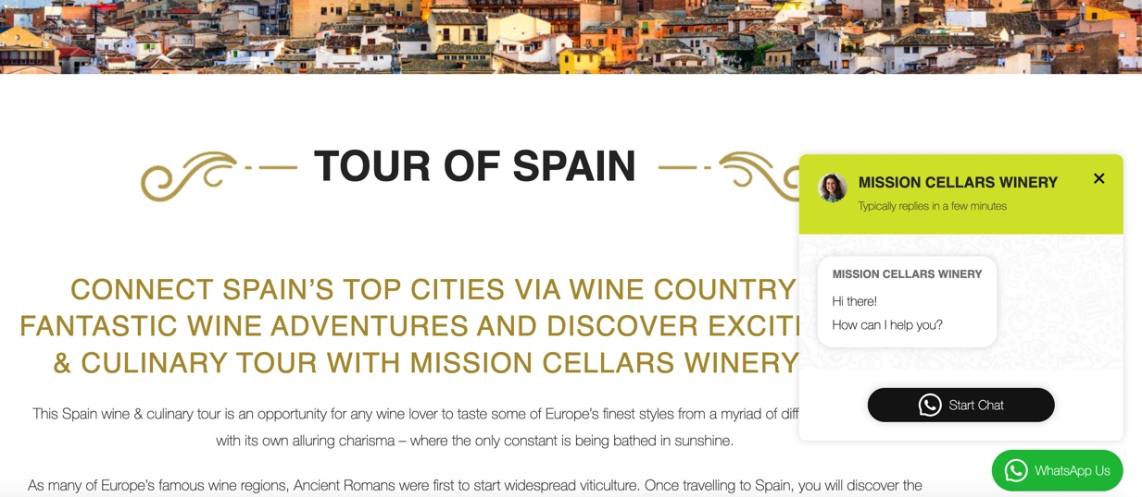

PHYSICAL ABILITY
This tour involves lots of walking that at times will be quite steep and on rocky terrain or uneven cobblestone streets. If you are physically unable to walk up the equivalent of six (6) flights of stairs in less than five (5) minutes, please do not make a reservation for this tour.

PASSPORT
Make sure your passport is valid for at least six (6) months past your return date.

Please scroll down for the hour-by-hour itinerary below but here’s an overview of the highlights. This will be a comprehensive, weeklong wine and culinary tour of Spain including La Rioja, Basque Country, Ribera del Duero and Ribera del Guadiana.
HOLD HARMLESS AGREEMENT
Upon registration you will be required to sign a hold harmless agreement.
The tour will start in Madrid and end in Cáceres.
If you choose to fly to Barcelona, it will take approx. 2h and 30 minutes from Barcelona Sants Train Station to Madrid (Atocha Train Station). Our hotel in Madrid is located in El Retiro, center of Madrid. Once in Madrid you will need to take a taxi in Atocha Train Station to the Hotel. Here's the Day by Day (subject to modification) itinerary.

ITINERARY

DAY 1. (B/D)
The first day we will meet in Madrid in the Hotel Palacio del Retiro:

Upon arrival at Madrid and because we know that after so many hours in a flight to Europe is exhausting, you will have a relaxing day. We arranged welcome lunch with a cooking class to enjoy how to learn and savor some Spanish traditional dishes such as paella, gazpacho, tortilla de patatas, etc. After the class, feel free to go back to the hotel and explore Madrid in your own until dinnertime. In the evening, we will take a taxi to enjoy a Flamenco show.

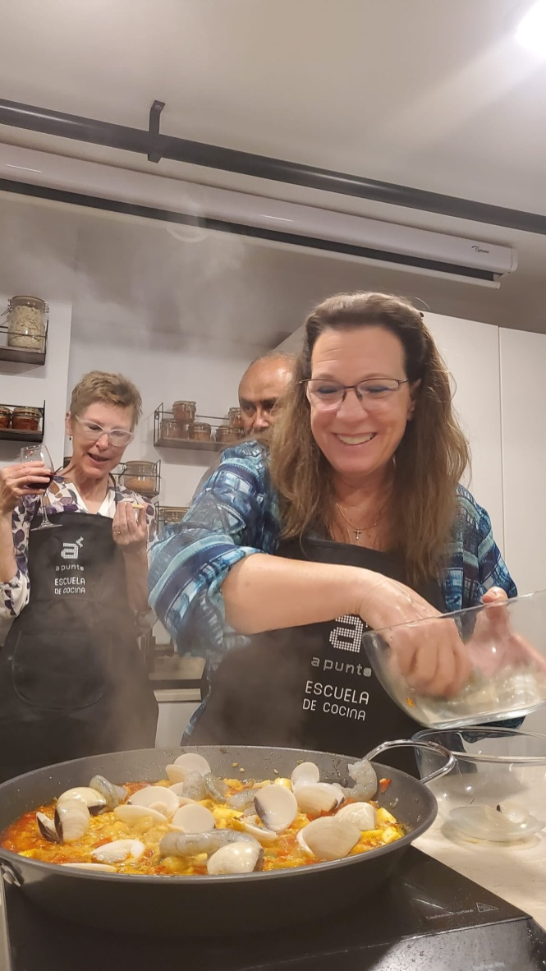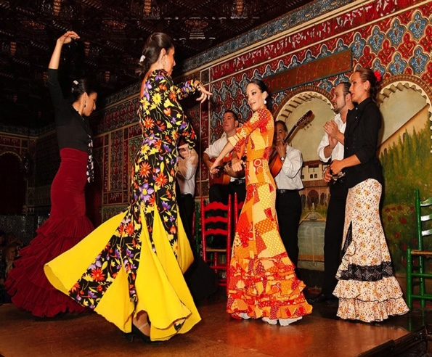
Cooking Class, Madrid. Picture Enjoy a Flamenco Show and the Night in Madrid
from last Mission Cellars Wine
Tour (May, 2023)

Day 2. (B/L)

Breakfast at the Hotel

Today we will depart to Aranda del Duero (Approx. 1:45min with our Private Bus). Aranda is in the heart of Ribera del Duero. This year Aranda de Duero proudly acts as the European Wine City, and has done so since 2020. In Aranda there are 135 medieval underground cellars, which form a seven-kilometer labyrinth under the old town (called Los Calaos) and make this city the great wine-producing center of northern Spain. We will visit a part of this labyrinth together where we are doing a Wine Tasting Class. Get ready to go underground. Here is some info from Aranda del Duero. We will arrive at Aranda del Duero about 11am or so do the check in and go to downtown right after. We will meet our guide for a tour to visit “Los Calaos”.
When we finish, we will go for lunch to “Aitana Restaurant” where we are going to taste a typical lunch prepared in a wood oven. After we are done, we will go back to the bus towards the Hotel where you are free for the rest of the day. Enjoy the rest of the afternoon anyway you want. At the hotel you can relax with the wine SPA*, a unique experience in a unique environment and setting. You will feel immersed in a unique space. The SPA consists of different options: hot pool, massage, sauna, steam bath, etc. Choose the one you like the most or don’t choose at all. Up to you! Here is the link.

*The Spa is not including in the Tour, but we can make the reservation for you.

Overnight Hotel: https://www.lagarisilla.es/
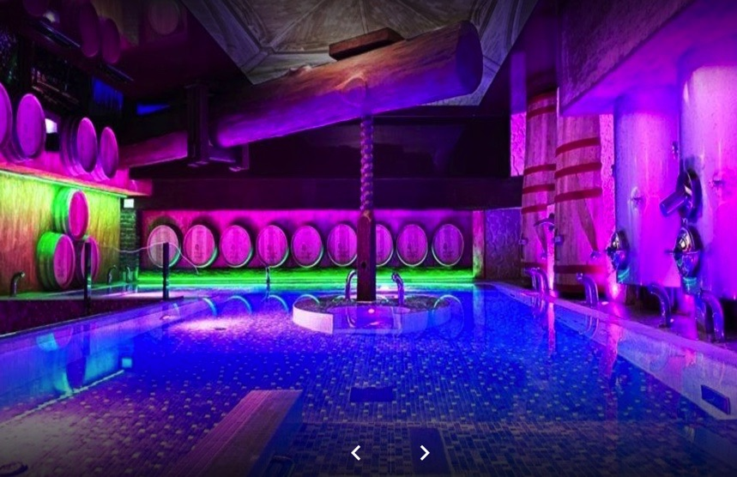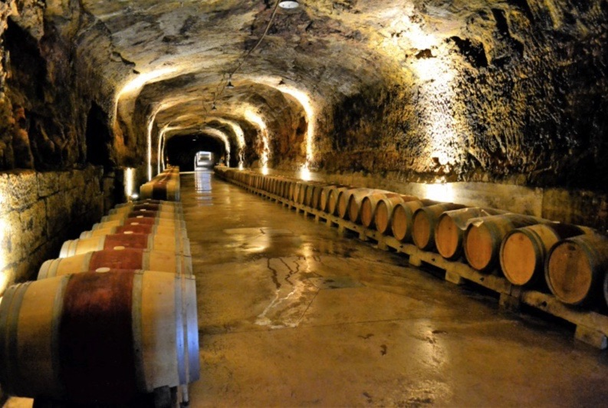
Wine SPA in the Hotel in Aranda Wine tasting in this genuine caves

Day 3. (B/D)

Breakfast in the Hotel

This day, we will stay in Aranda enjoying this special hotel. We will visit a cave with Lydia, the owner of the hotel for a wine experience with her and her team in town. After that, you can enjoy this little town and we will meet you at 8pm for dinner in the hotel.

Overnight Hotel: https://www.lagarisilla.es/

Day 4. (B/D)

Breakfast in the hotel

We will depart from Aranda del Duero to Briñas, La Rioja. It will take us about 2h, but before we are going to stop in Haro. Trent and Silvia will give you a map with all the information for the next stop, “Barrio de la Estación” in Haro. Get ready! Haro is the Capital of La Rioja Wine Region (https://www.haroturismo.org/en/enoturismo/el-vino).
About noon, we will be in the Museum Vivanco (https://vivancoculturadevino.es/es/fundacion/museo-vivanco/) where we will do a visit to this fantastic Wine Museum and we will have a wine tasting with our personal guide, Rebeca. After that, we will go to the hotel and get ready for dinner in the best Michelin Star Restaurant in Haro: El Nublo (https://www.nublorestaurant.com/#home). Get ready for the best culinary experience you ever had before in Spain. You are going to LOVE IT!!

Overnight Hotel: https://www.marriott.com/en-us/hotels/vitbk-palacio-tondon-la-rioja-brinas/overview/

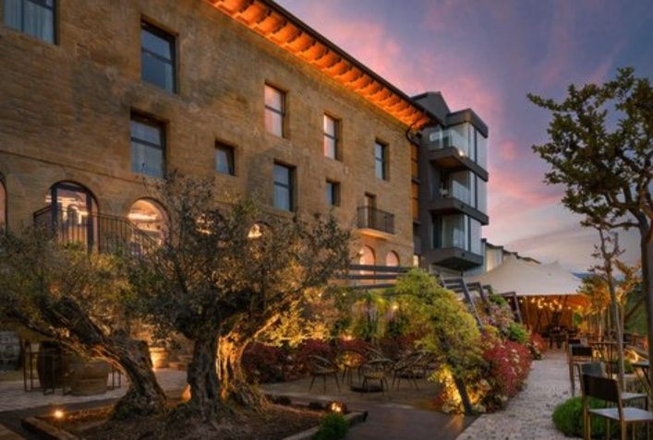
Palacio Tondon, Hotel in Briñas

Day 5. (B/D)

Breakfast in the Hotel

Three Fun and Fantastic Option we offer today:
- Take a Balloon Flight to see the Wine Region from the air. This activity takes 4h. Here more info: http://www.globoslarioja.com/en/balloon-flights/groups-balloon-flights.html

OR…

- Visit the Cheese and Olive Oil Factory “Los Cameros” (https://www.loscameros.es/en/visits-cheesemaking-creamery)

OR….

- Visit the Vinegar factory next door to Cheese Factory “Los Cameros”
(https://www.vinaharo.com/en/)

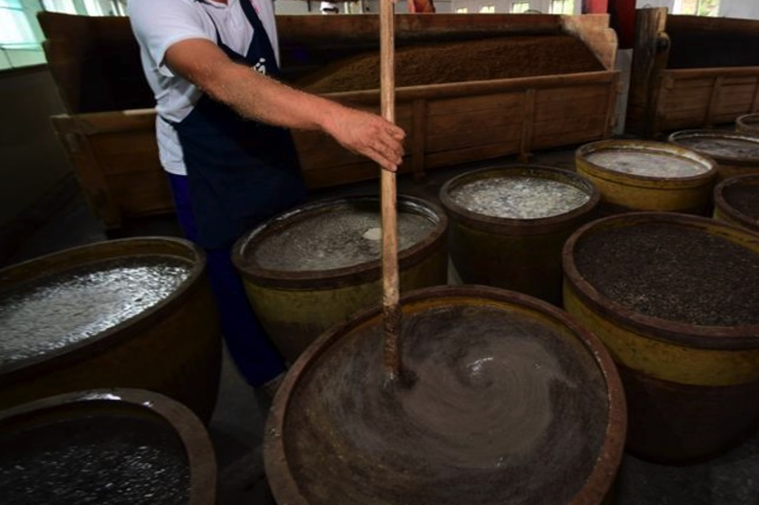
Vinegar factory, La Rioja

The plan for this day is to have separate groups having fun almost at the same time. The ones that don’t go to ride the Hot Air Balloon, we will depart to the picturesque town of Ollauri (10min from Haro) to visit Hemmingway’s favorite Winery “Conde de los Andes” (https://www.bodegasollauri.com/en) with 500 years of history. Ernest Hemingway visited these “calaos” at the end of September 1956, which consist of a 1 kilometer underground cellars, in local speak. His wife, Mary Welsh, and a great friend, the bullfighter Antonio Ordóñez accompanied him. You will have the opportunity to take a picture in the sofas where Hemingway was having a glass of this spectacular wine.
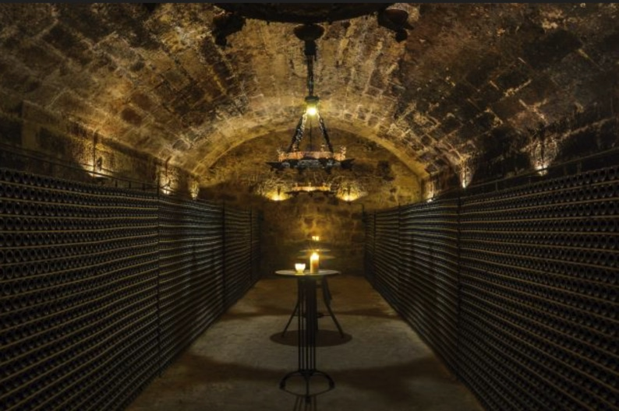Bodega Conde de los Andes, La Rioja
The writer was at the peak of his career and fame. He had already been awarded the Pulitzer and the Nobel Prizes, and was very popular all over the world. He lived between Idaho, in the United States, and his estate on the outskirts of Havana, although he never ceased to spend long periods of time in Europe. His presence that day in Ollauri was part of his second trip to Spain in the 1950s. He went on to visit the country in the summers of 1959 and 1960.
We will have a tour, tasting and small snack in Winery Conde de los Andes and then, we will have dinner in Briñas altogether again. We will love to share stories about those who ride the Hot Air Balloon.
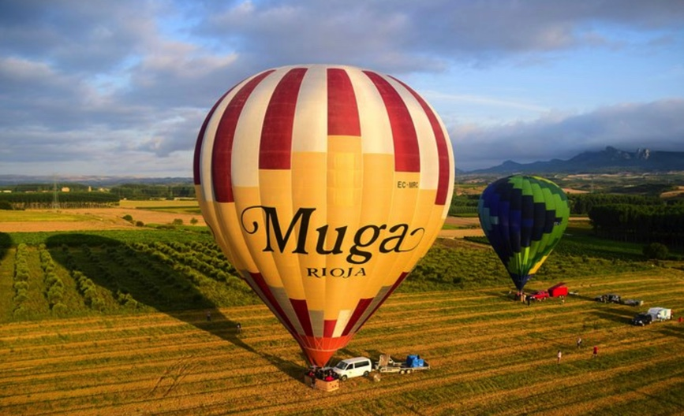
Hot Air Balloon, La Rioja

Day 6. (B/D)

Breakfast in the Hotel

This day, we will depart to Marques de Riscal Winery (https://www.marquesderiscal.com/visit-us) for a Wine tasting and Culinary Tour. When the tour is over, the group is going to the Bus because we are heading to the new exciting Wine Region down South, Pesqueira. The drive is going to be around 2:40min. When we arrive to the Pesqueira region, we will all going to check into the 5* Hotel SPA Arzuaga (https://www.hotelarzuaga.com/index.php/hotel.html) where you will be free for the rest of the afternoon. Something fun to do in the hotel it will be the SPA and the wine massage experience. Check the website for more details. And for dinnertime, lets all meets in the Bar for some tapas for a wonderful end of the day.

Overnight: 5* Hotel SPA Arzuaga (https://www.hotelarzuaga.com/index.php/hotel.html)

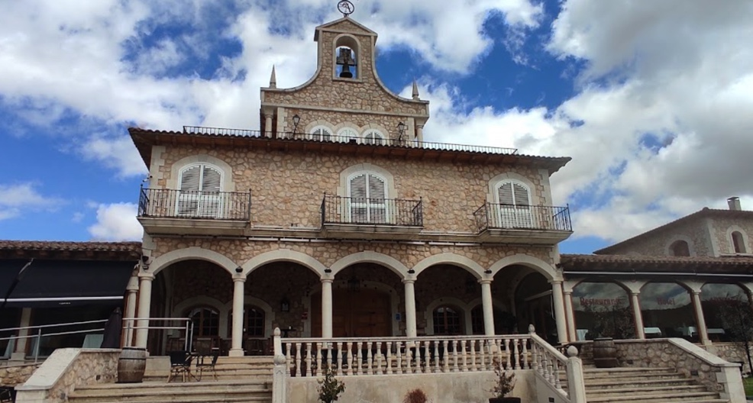
Hotel Arzuaga, Valladolid

Day 7. (B/L)

Breakfast in the Hotel

We will have different experience today. Visit Finca La Planta and its wild fauna reserve of deer and wild boar, also discover the interior of the Arzuaga Winery and taste three of its famous wines. But if you prefer to stay in the SPA, you will have the 10% off!! After all this fun, we will have lunch together and we will depart to Tierra de Zamora: Castillo del Buen Amor. We will be in the bus around 1h50min. Here the link for the hotel: https://www.buenamor.net/
After we arrive to El Castillo del Buen Amor, the rest of the day is to enjoy the Castle and grounds, relax, explore and drink wine with friends anywhere in any room you want in the Castle. Don’t get lost! We will have dinner is in your own today!

Day 8. (B/D)

Breakfast in the Castillo

Different options today:
- Go for a Horse Ride through the Tormes River
- Or go to visit Salamanca for some shopping and admire the beautiful arquitecture! You will not regret!

When you come back, we will have some Wine Tasting in the Castle and dinner all together.

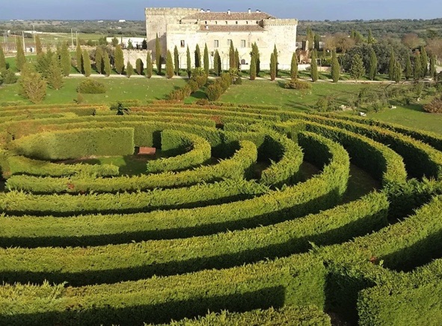
Castillo del Buen Amor, Salamanca
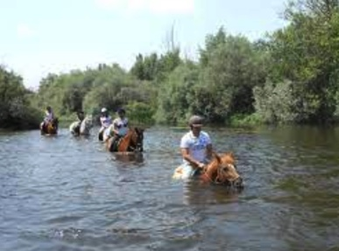
Riding a horse experience in Tormes River

Day 9. (B/L)

Breakfast in Hotel

Depart to Guijuelo (1h). Stop in Guijuelo to start the Class of cutting Spanish Jamón and tasting followed by a visit to the Jamón factory (2h). Then, we will have lunch in the Jamón Factory and get ready for the beautiful Medieval town as we depart to Trujillo. The drive is going to take 2h. Enjoy the ride!
When we arrive to Trujillo, we will check in into the 14th Century Renaissance Palace Hotel-Parador (https://paradores.es/es/parador-de-trujillo) first thing set in the Old town inside the Moorish and Medieval city Walls. Let yourself be carried away by its beauty.
Before dinner, we will have a guided Tour, we will meet you in the Lobby of the Parador to start the visit of the city of Trujillo, here more info: (https://www.spain.info/en/destination/trujillo/)

More websites to check:
https://www.jamonturismo.es/.

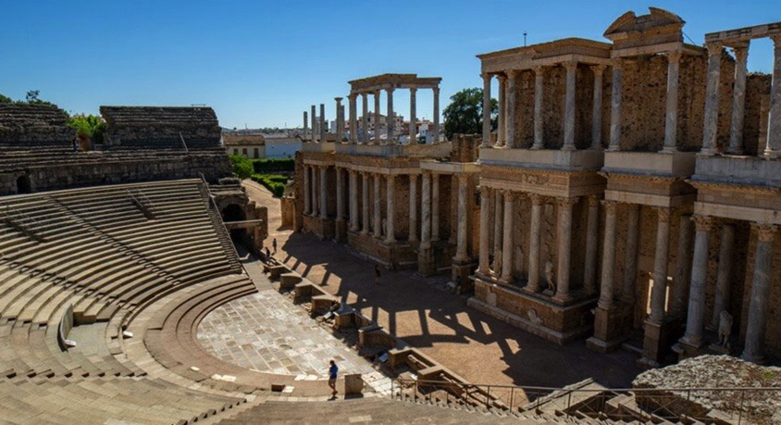
Mérida city. Part of the Roman Empire
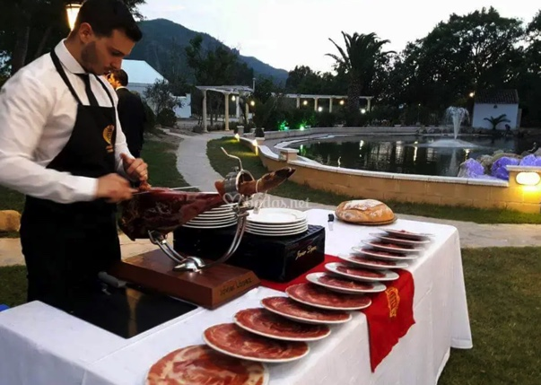
Cortador de Jamón

Day 10. (B/D)

Breakfast in the Hotel Parador

We are almost in the end of the tour. We finish the tour in famous Winery from Ribera del Guadiana River called HABLA (https://www.bodegashabla.com/). We will visit the vineyard and we will taste their fabulous wines. After that, we will have dinner in La Plaza de Trujillo and you are free for some shopping around this incredible town.

Enjoy Caceres in nighttime on your own.

http://restaurantelacasadelsol.com/

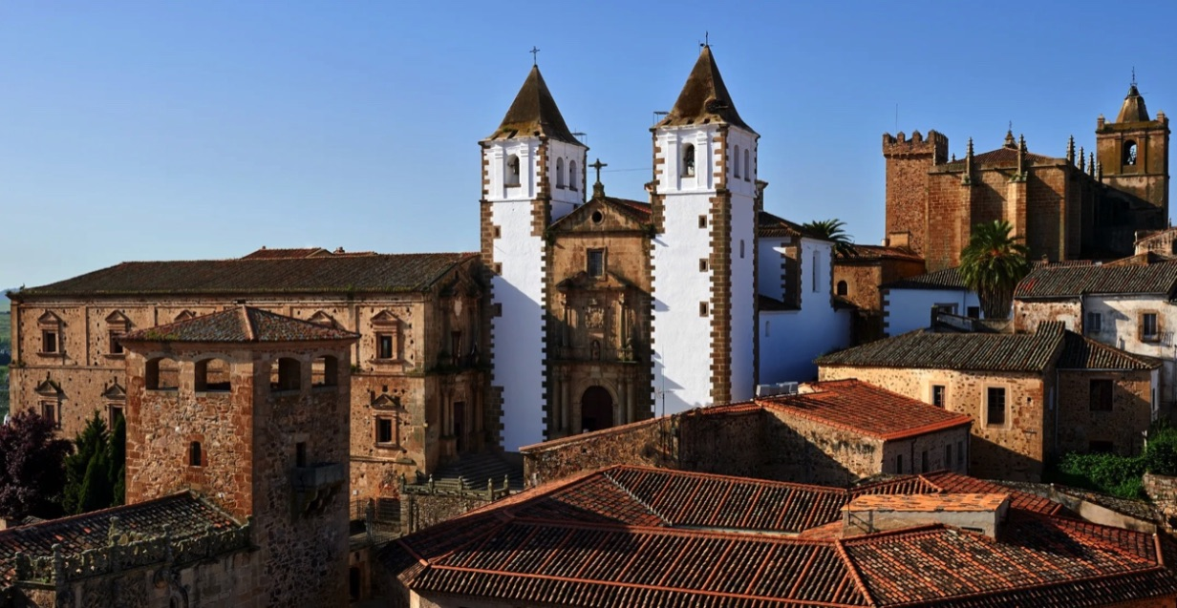
Cáceres city

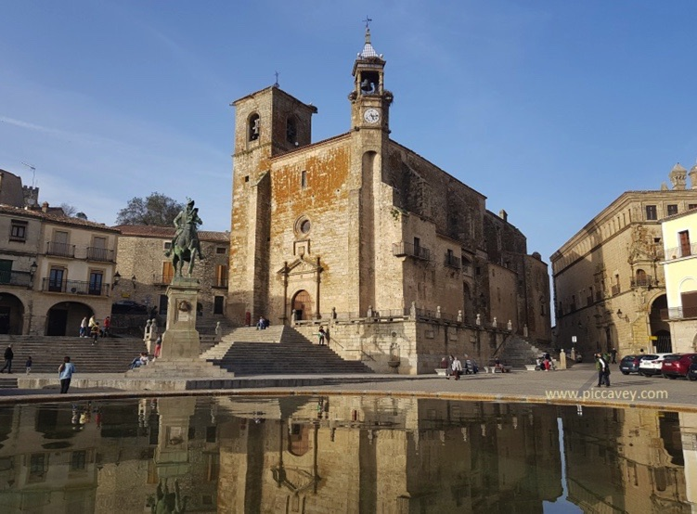
Trujillo city

Day 11 (B)

Breakfast in the hotel

Trent and Silvia will be there for you to arrange taxis to go to the Bus/Train or Rental Car to Madrid or Barcelona. Check out will be mid-morning and naturally, the Parador will be more than happy to look after your luggage for the day if you have an evening bus/train.

RSVP
Please reply back to this email with everyone in your party's:
1. Full names
2. Cell phone numbers and best date/time to call for your credit card info
3. Email addresses
4. Whether you want one or two beds
5. Whether you want a standard room or a deluxe suit

SIGN UP HERE

…and let’s have fun!

https://www.renfe.com/es/en
https://www.renfe-sncf.com/rw-en/services/stations/Pages/madrid-puerta-de-atocha.aspx)
https://www.marriott.com/en-us/hotels/madre-hotel-palacio-del-retiro-autograph-collection/overview/?scid=f2ae0541-1279-4f24-b197-a979c79310b0
https://www.spain.info/en/destination/aranda-de-duero/
https://www.turismocastillayleon.com/en/art-culture-heritage/monuments/ethnological-site/wine-cellar-aranda-de-duero
https://aitanarestaurante.es/
https://www.lagarisilla.es/en/spa/spa-del-vino/

